Trampolining Newsletter

Spring/ Summer Term 2016

|  |
| --- |
| Jess cliff at ndp trampolining  Congratulations to Jess, who competed at the NDP Trampolining Competition on 9th July 2016 with Central Galaxy Coventry Trampolining.  It was Jess’ first time competing with a 6.8 tariff and she has done amazingly well, coming 5th in the country in the NDP 6 category.  We are thrilled for her success and can’t wait to see what she manages next year. |
|  |
| https://scontent-lhr3-1.xx.fbcdn.net/v/t1.0-9/13615338_10209227449230619_4964048194960990260_n.jpg?oh=b7453c140405fa72e303019550f9fd2f&oe=582F5E57 |

Jess Cliff competing at the NDP, image owned by Jess Cliff.

# TRAMPOLINING COMMITTEE 2016-2017 ANNOUNCED

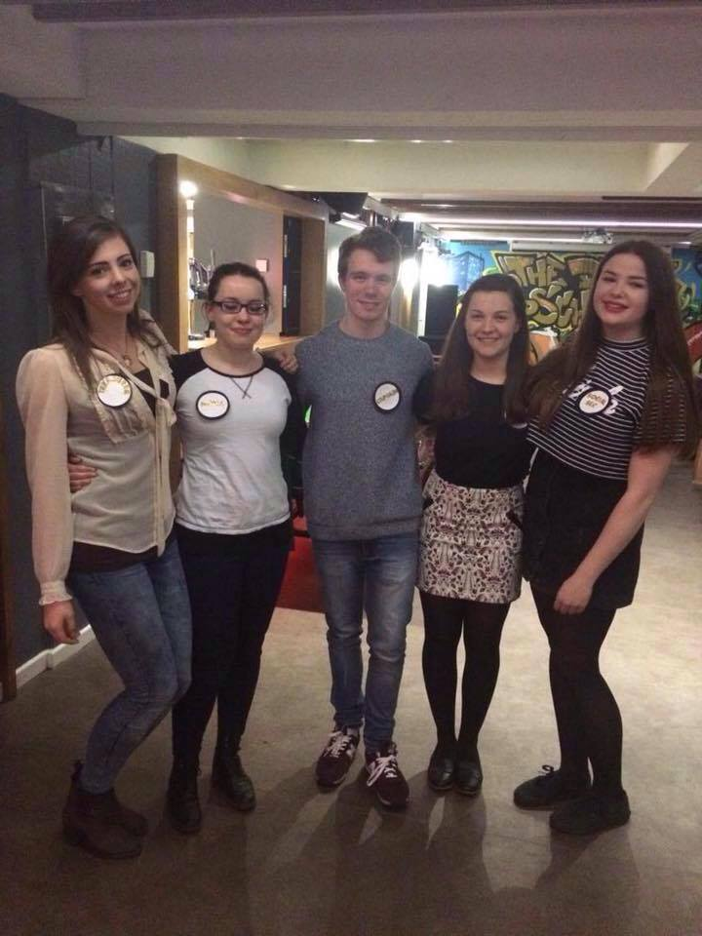We are pleased to announce that our committee for the 2016-2017 season will be as follows:

* Club Captain: Tom Senter
* Trampolining and Competition Rep: Natalie Holford
* Social Secretary: Sophie Mathewson
* Treasurer: Anna Lyndon
* Media and Marketing Rep: Ellen GM
* Secretary: Beth Maidment

This was announced following the AGM in March.

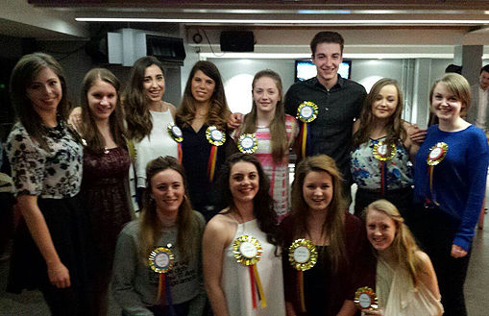Thank you to everyone who stood for election.

The new committee take over from Ellie Joseph, Anna Lyndon, Hannah Poland, Emily Beards, Alice Williams and Jess Cliff. We would like to thank them for all their hard work over the 2015-2016 season.

SPLIT FROM GYMNASTICS

As current members will be aware, for the 2016-17 season we will be splitting from the Gymnastics Club. This has unfortunately resulted from the building of the new sports centre, which does not provide a gymnastics hall unlike the Munrow.

However, the two clubs intend to maintain close links including a shared website, shared Facebook page and joint Sports Nights. We hope to reunite in the future.

# 

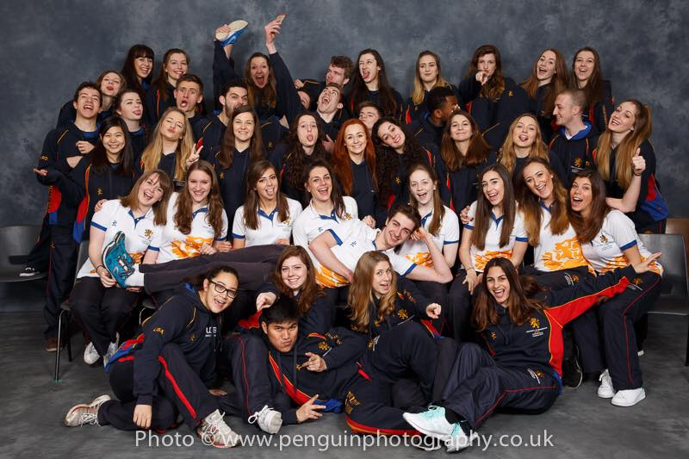

Fun Club Photo for Trampolining and Gymnastics 2015-2016

Social Media Links

Trampolining:  
Instagram - trampoliningclubbrum  
Twitter - trampolininguob  
Snapchat – trampolininguob

Website- <http://gymtrampbrum.wix.com/gym-tramp>

Email- trampoliningclubbrum@gmail.com

# 

# BUCS ROUNDUP

We had a fantastic BUCS competition with the following results:

BUCS 4:

George Killick 12th

BUCS 6:

Megan James14th

Beth Harvey15th

BUCS 1:

Ellie Joseph 4th

Alice Day 8th

Jess Cliff11th

BUCS 2:

Tom Senter 2nd

Imogen Pickup11th

Please contact our new Media Rep (Ellen) if you are interested in writing a blog post for the website, having your photographs or videos featured on our Instagram page or want to find out more about photography and filming opportunities at competitions next year.

You can do this via our email address, Facebook or contacting us through the website.

# cONGRATULATIONS TO ALL OUR COMPETITORS, YOU WERE AMAZING.

Friday

17:00 - 19:00 - Inter-Advanced and Advanced

​

Saturday

 14:30 - 15:45 - Squad

15:45 - 17:00 - Non Squad Open Session

Training times for the 2o16-2o17 are as follows:

Monday

16:30 - 17:45 - Novice and Intermediate

17:45 - 19:00 - Inter-Advanced and Advanced

Wednesday

13:00 - 15:00 - Novice and Intermediate